**ASSIGNMENT OF PYTHON SESSION #7**

Q. 1. Whatsapp texting using webbrowser module.

Ans.

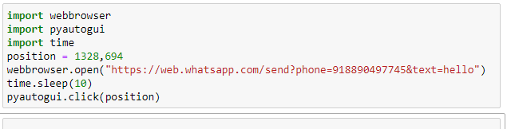

Q.2 You have to Make a WhatsApp Script

-> Till now we have seen about sending message in WhatsApp through Python using Webbrowser.

-> run a program and send a same message to 6 persons through a script.

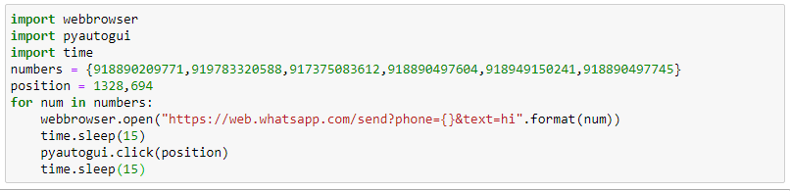

-> Script to send "Hi" 5 times to a friend

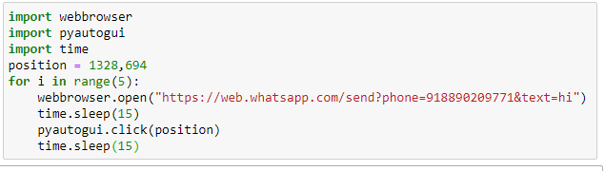

-> then you have to monitor your friend that your friend is online or not and if he is online then what's the time and save it in .csv file format.

Also run your script and calculate how much time your friend gives on WhatsApp in a Day (perform it for a specific period of time)